

Final Report

Title**： Garbage classification technology and visualization**

number 20202505019

name  Ethan

college international college

major software engineering

class class 1

2023年 6 月 3 日

Garbage classification and recognition technology and visualization

Abstract

Garbage classification and recycling can achieve garbage resource utilization and reuse, while improving urban living environment and saving energy

Abundant resources promote sustainable development of production, consumption, and economy. At present, traditional garbage classification technology has low efficiency and accuracy, and lacks intelligent and automated recognition methods. Image recognition technology based on intelligent terminals provides the possibility for intelligent automatic garbage classification. This article addresses the issues of limited data samples, limitations in multi-objective garbage recognition, and complex environmental interference recognition in image recognition based garbage classification. By constructing a garbage image dataset, a research on garbage recognition and classification models based on convolutional neural networks is carried out, providing new ideas for the automation and intelligence of garbage classification. Specific research contents include: research on garbage image classification model based on transfer learning. Aiming at the problem of small data set in the training of garbage image classification model based on deep learning, a method combining transfer learning and convolutional neural network is proposed. The DenseNet169 model is first pre trained on the ImageNet dataset, and then the model parameters are transferred to the NWNU-TRASH garbage image dataset constructed in this article for parameter fine-tuning to improve the classification accuracy of the model. The experimental results show that the classification accuracy of this model reaches 82.80%, which is significantly higher than other classical image classification models, and the model takes the shortest time. This shows that the model proposed in this paper is more suitable for garbage classification than other methods. Therefore, it is effective to combine transfer learning and convolutional neural network to classify garbage images.

Keywords: garbage classification; Deep learning; Image recognition; Target detection;

Catalog

1. introduction

1.1 Research background and significance…………………4

1.2 Analysis of the current research status at home and abroad…………………………………………………………8

2 Garbage Image Classification Model

2.1 data set……………………………………………………12

2.2 Construction of garbage image classification model……13

2.3 Experimental results and analysis………………………15

**3 Multi-objective garbage recognition model**

3.1 Construction of multi-objective garbage image dataset…19

3.1.1 Dataset Collection………………………………………19

3.1.2 Data annotation…………………………………………20

3.1.3 Small size garbage image recognition problem………………21

3.2 Method for constructing feature fusion models…………22

3.3 Experiment and analysis…………………………………24

**4 References***…*…**…**……………………………………………29

**5 appendix**……………………………………………………29

**6 Code**…………………………………………………………30

1. introduction

**1.1 Research background and significance**

In recent years, with the rapid development of China's economy, the variety of daily necessities has gradually enriched, and the quality of life of residents has increased.

At the same time as the continuous improvement, the production of household waste is also increasing, which has caused enormous pressure on the ecological environment of our country. Statistics show that the total output of garbage in urban areas of China is as high as 160 million tons per year, and the total amount of garbage in rural areas is not less than 150 million tons per year. Existing predictions indicate that China's annual waste production will increase to 548 million tons by 2035 and 652 million tons by 2050. The production of household waste is increasing year by year. If it is not treated properly and timely, the waste problem will have a serious impact on the health of the people and pose a huge threat to the ecological environment. At present, China mainly treats garbage through three methods: landfill, composting, and incineration. Among them, the most important treatment method is landfilling, which involves burying garbage in specialized landfills for long-term natural decomposition. This not only occupies a large amount of land, but also causes serious pollution to soil and water resources. Composting refers to the transformation of organic matter contained in garbage into corrosive fertilizer for use by soil microorganisms. Although composting can recycle resources to a certain extent, it can also lead to soil compaction and water pollution. The fly ash generated during garbage incineration not only causes serious air pollution, but also enters the respiratory tract of residents with the circulation of air, posing a threat to their physical health.

In a sense, garbage is just a resource that has been misplaced and recycled in a certain way,Turning waste into treasure is also a hot research topic today. Domestic waste contains a large number of recyclable components, which can be classified and placed according to certain established rules. This means that waste is classified, processed, and recycled, and resources can be re integrated. This not only protects the environment, but also saves a lot of resources, achieving sustainable economic development. Garbage classification is not only a practical problem, but also a scientific problem. In recent years, although China has vigorously promoted garbage classification, looking at the current implementation of garbage classification, it can be seen that the implementation of garbage classification and collection is mainly in economically developed first tier cities, while economically underdeveloped cities and rural areas have not made practical progress in garbage classification. Statistics show that the amount of domestic waste generated in China is much higher than its clearance, indicating that a portion of the waste cannot be disposed of in a timely manner. The main reason for untimely garbage disposal is low processing efficiency, mostly through manual sorting. Different subjective judgments can lead to incorrect classification of garbage and consume a lot of time. There is no clear punishment system for the indiscriminate discharge of garbage in our country, and the arbitrary disposal of garbage increases the difficulty of manual sorting. Working in such harsh environments for a long time can also have a certain impact on the physical health of sorting personnel. With the advancement of technology, automation technology is gradually applied in various fields, and machines are gradually replacing human labor to perform a large number of repetitive and tedious tasks. Computer vision emerged as the times require, and computers are used to simulate human visual functions and perceive the real world by processing captured images or video information. With the continuous progress of artificial intelligence and image recognition technology, using computers to replace manual garbage disposal.Automated classification has become a current research hotspot. The use of image recognition methods to classify captured garbage images is a technical prerequisite for achieving automated garbage classification, which can achieve more efficient and accurate classification results than manual work. The research significance of this article is as follows: Firstly, a new recyclable garbage image dataset was constructed to address the issue of certain defects in existing public garbage datasets. The newly created dataset has data balance and diversity, providing strong data support for this study. Secondly, although there are currently many mature image recognition technologies, their applications in the field of garbage classification are relatively few. The forms and colors of garbage are diverse, with significant differences in size, and complex feature information carried. Moreover, due to the influence of garbage classification scenarios, the background of garbage images is generally messy, resulting in low recognition accuracy of existing algorithms for garbage, and the recognition speed cannot meet the real-time recognition needs of garbage in practical applications. This article applies deep learning methods to the field of garbage classification and constructs a garbage recognition and classification model based on convolutional neural networks. Finally, different improvements and optimizations were made to the newly constructed model for specific problems, achieving the goal of identifying the category of garbage by identifying the input garbage images. The model constructed in this article can make up for the shortcomings of existing model methods, enrich the application of image recognition technology in the field of garbage classification, and improve the subsequent garbage classification.

Classification research has certain theoretical significance. The practical significance of this article is: firstly, the primary task of garbage treatment is to correctly classify garbage. Implementing garbage classification can not only reduce environmental pollution and improve residents' living conditions, but also screen out recyclable garbage and reuse resources, truly achieving "turning waste into treasure". Secondly, the traditional manual sorting of garbage not only slows down the sorting speed, but also causes physical harm to the garbage sorting personnel due to long-term work. With the advancement of technology, automation technology can replace manual labor in repetitive and heavy work, with relatively higher efficiency. Finally, computer vision plays an important role in automated garbage classification, and correctly identifying garbage categories in images is a prerequisite for achieving automated garbage classification. The garbage recognition and classification model based on convolutional neural networks proposed in this article has the dual advantages of lightweight and real-time performance. It can efficiently and automatically classify garbage through embedded devices or intelligent mobile terminals, and has significant practical significance.

**1.2 Analysis of the current research status at home and abroad**

In some developed countries abroad, garbage classification has been implemented for a long time and gradually evolved into corresponding policy systems. The classification of garbage categories in the United States is not very detailed. Garbage is simply divided into two or three categories. The recycling, treatment, processing, and sales of household waste are a complete and systematic industrial chain that operates under a relatively mature business model. Germany attaches great importance to the recycling and reuse of garbage, has a strict garbage classification system, and utilizes a series of laws to ensure the implementation of garbage classification. Japan has conducted a very detailed classification of garbage, not only emphasizing the promotion and education of garbage classification, but also establishing very clear and comprehensive garbage treatment laws. Detailed classification of garbage has become a common practice among Japanese residents and is closely related to their daily lives. With the continuous implementation of garbage classification, many domestic scholars have also conducted research on China's performance in garbage classification. Zhang Yingmin and others objectively evaluated the advantages and disadvantages of each of the three main waste treatment technologies, as well as their application status in China. They found problems in the various stages of household waste cleaning, disposal, and management, and proposed suggestions for implementing classified collection of waste. Peng et al. studied the development process of garbage classification in China, analyzed the problems and obstacles in the garbage classification process, and provided corresponding countermeasures for the management. Garbage classification and recycling is an effective method to solve the problem of urban garbage, but the lack of participation by residents is a major bottleneck in implementing garbage classification policies, and there are many factors that affect residents' participation in garbage classification. Wang Dandan et al. explored the impact of government incentive mechanisms on residents' garbage classification behavior by constructing an evolutionary game model of government regulation enterprise processing residents' participation. The study found that if the benefits of participating in garbage classification are at least twice the cost of participating, residents will have the motivation to participate in garbage classification. The structural equation model was used to study the impact of environmental attitudes, subjective norms, and perceived behavioral control on residents' garbage classification behavior under strong policy backgrounds. The results showed that the above three factors have a positive impact on residents' willingness and behavior to classify garbage. Liu Jingxuan et al. constructed a systematic research framework based on the theory of multi center governance from the social to psychological levels to study the factors that affect residents' garbage classification behavior. Research has found that factors such as government promotion and education on garbage classification, the level of improvement of garbage classification facilities, standardization of garbage collection systems, social demonstration power, and public perception can positively affect residents' garbage classification behavior. Lin Tong et al. used principal component analysis to explore residents' willingness to participate in garbage classification and its influencing factors. The results showed that:

Willingness is mainly influenced by age, awareness of convenience, satisfaction with community waste management, and reward and punishment mechanisms. Deng Jun and others investigated the implementation of garbage classification in 600 garbage classification communities in Beijing. The survey found that the accuracy of garbage classification is not high, and the main reason for this problem is the low awareness rate of garbage classification related policies and knowledge among residents. 60.1% of residents have poor awareness of the waste classification standards. Most residents are not familiar with the classification standards and specific rules for garbage.

Garbage classification is a necessary path to achieve resource recycling and sustainable economic development. Want better implementation

It is far from enough to rely solely on the public's self-awareness and subjective judgment of garbage classification. It is unrealistic to rely on the subjective consciousness of the public to determine the category of garbage, which requires a thorough understanding of the classification standards for garbage. Due to individual differences among residents and different educational backgrounds of different groups, it is very difficult to achieve a nationwide understanding of the classification standards for garbage. Hiring a large number of professional sorting personnel to manually sort garbage can lead to difficult problems such as high workload, easy sorting errors, and low sorting efficiency. In recent years, scholars have proposed intelligent garbage recognition and classification methods, which achieve automated classification through machine recognition of collected garbage images, thereby reducing manual sorting costs, improving garbage processing efficiency, and resource reuse.

1. **Garbage Image Classification Model**

**2.1 data set**

At present, there are relatively few publicly available garbage datasets, with the most typical representative being the TrashNet dataset, which includes six types of recyclable garbage images: glass, paper, cardboard, plastic, metal, and trash. The total number of datasets is 2528. Currently, most research on garbage classification based on image recognition uses the TrashNet dataset. However, this dataset also has shortcomings: (1) the sample data size is too small; (2) Uneven distribution of different types of garbage images in terms of quantity; (3) The single background of the image does not meet the needs of real-world classification scenarios and is not conducive to training the model's generalization ability. Based on the shortcomings of the above TrashNet data set, this chapter has built a garbage image data set named NWNU-TRASH through web crawler technology and manual photography, as shown in Figure 2-1, including five types of recyclable garbage [43], including waste glass, waste cloth, waste paper, waste plastic, and scrap metal, with a total of 18911 pictures. The images have chosen various backgrounds, and the distribution of garbage images of different categories is basically balanced in quantity, with high data diversity, which is more in line with the needs of real-world classification scenarios. The training and testing sets are randomly divided into mutually exclusive parts in a ratio of 7:3. The detailed data description is shown in Table 2-1.

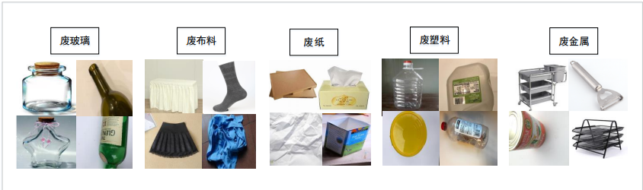

Table 2-1 Schematic diagram of NWNU-TRASH dataset

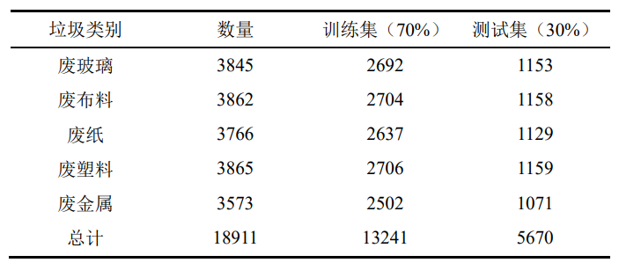

Table 2-1 NWNU-TRASH Dataset Information

**2.2 Construction of garbage image classification model**

The training of convolutional neural networks requires a large amount of data, and the network model trained under insufficient data storage

In the "data bottleneck" problem, and prone to "overfitting" phenomenon, can not achieve the ideal classification effect. In addition, training a new network model requires high requirements for computer hardware configuration, which not only consumes a lot of time and computing resources during training, but also consumes a lot of resources during parameter tuning, sometimes even failing to produce expected results. The transfer learning method can solve the problem of insufficient training data in the target field, that is, the knowledge or model learned in a certain field or task can be applied to different but related fields or problems. Therefore, this chapter constructs a garbage image classification model based on transfer learning, as shown in Figure 2-2.

The process of transfer learning is as follows:

(1) Enter the garbage sample image. Extract 70% of garbage images from the NWNU-TRASH dataset,

Input the network as a training dataset.

(2) Pre processing. Transform the size of the input sample image to the pre trained model's specified input size

Small.

(3) Build a garbage image classification model.

(4) Parameter migration and fine-tuning. By transferring the pre trained model parameters, the model is

Initialize parameters, set training rounds, learning rates, momentum parameters, etc., and then freeze the parameters of partial pooling layer and convolution layer by iterating the loss function, train the parameters of Softmax layer and full connection layer, and optimize them.

(5) Model testing. Extract the remaining garbage images from the NWNU-TRASH dataset for testing

Sample set to test the classification performance of the model.

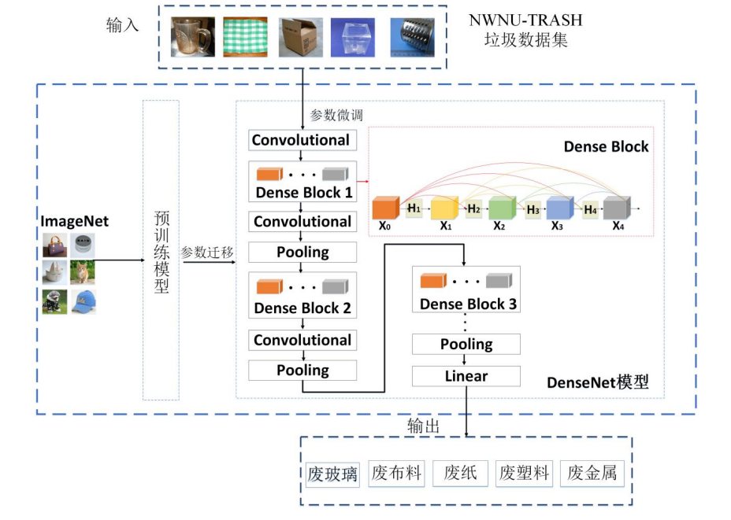

Figure 2-2 Garbage image classification model based on transfer learning

**2.3 Experimental results and analysis**

The training model in this chapter has a special evaluation index - confusion matrix for classification problems under the Python deep learning framework. Figure 2-5 shows the confusion matrix of the garbage classification model on the test set after 300 rounds of experiments. The darker the color, the more accurate the model classification. Figure 2-5 (a) shows the confusion matrix of the prediction results. The abscissa represents the prediction value output by the classification model, and the ordinate represents the real category of the garbage samples in the test set. The values on the diagonal represent the number of correct garbage image classification in the model, while values outside the diagonal represent the number of classification errors in the model [56]. For example, the number 917 in the upper left corner represents that 917 waste paper images in the test set were correctly classified by the model; The number 67 in the first row and second column represents that 67 waste paper images in the test set were mistakenly classified as waste plastic by the model. The number 139 in the second row of the first column represents that 139 waste plastic images in the test set were mistakenly classified as waste paper by the model. The diagonal value in Figure 2-5 (b) represents the prediction accuracy ratio. The classification accuracy of waste paper, waste plastic, waste glass, scrap metal and waste cloth is 81%, 69%, 84%, 84% and 96% respectively. From the confusion matrix, it can be seen that the classification accuracy rate of garbage in the category of waste cloth is the highest. By viewing the garbage images in this category, it is found that the images of waste cloth have more obvious features and less image interference information than the other four categories. However, the classification accuracy of waste plastic is the lowest. By looking at the images, it was found that this category of images is relatively chaotic, which affects the recognition accuracy.

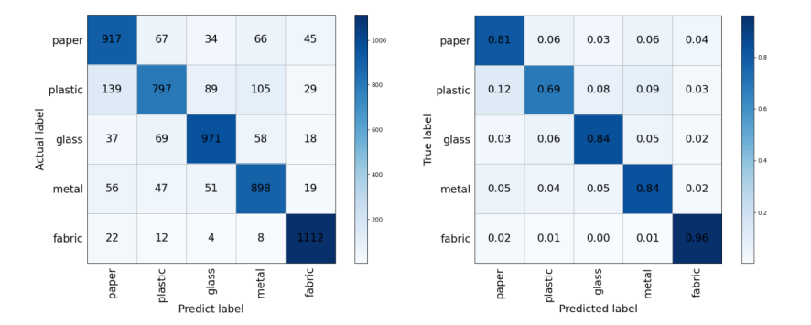

The classification effect of each category is shown in Table 2-3. This chapter uses multiple evaluation indicators to evaluate the model classification results.

According to Table 2-3, the Accuracy and Recall of waste paper in this category are both 81%, Precision is 78.64%, and F1 score is 79.80%; The four indicators of waste glass in this category are all 84%; The accuracy and recall of scrap metal is 84%, the precision is 80%, and F1 core is 81.95%; The accuracy of waste plastic in this category is 69%, Precision is 80.23%, Recall is 68.32%, and F1 score is 73.80%, which is the lowest among all waste categories; The accuracy of waste fabric is 96%, Precision is 89.72%, Recall is 96%, and F1 score is 92.75%, which is the highest among all waste categories. It can be seen that the model constructed in this chapter has the best classification effect for waste fabric.

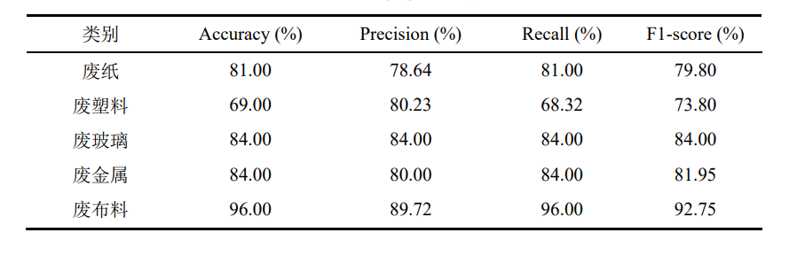

Table 2-3 Evaluation Indicators of Garbage Classification Model

The ROC curve is another indicator for testing the classification performance of a model. The ROC curve of the model constructed in this chapter is as follows

As shown in Figures 2-6. In the ROC diagram, the horizontal axis represents False Positive Rate, which is FPR, and the vertical axis represents True Positive Rate, which is TPR. The specific meanings are given in Table 2-2. AUC represents the offline area, and the larger the offline area, the better the classification performance of the model. From Figure 2-6, it can be seen that the waste category curve representing waste fabric is located above all curves, with the largest area enclosed by the horizontal axis. The waste plastic curve is located at the bottom, and the offline area is the smallest. This indicates that the classification effect of images such as waste fabric is the best, while the classification accuracy of waste plastic is relatively the worst.

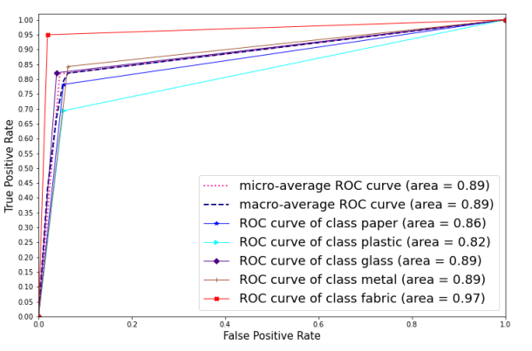

Figure 2-6 ROC curve

1. **Multi-objective garbage recognition model**

**3.1 Construction of multi-objective garbage image dataset**

**3.1.1** **Dataset Collection**

The vast majority of garbage image datasets currently used in research have only a single garbage image, which is difficult to fill

Meet the needs of practical problems. This chapter collected and constructed a multi-objective garbage image dataset called MULTI-TRASH through camera photography, which contains the same garbage categories as the single target dataset in Chapter 2. The initial images were a total of 2005. In order to ensure that the constructed garbage recognition model can complete garbage image recognition in real garbage classification scenarios, the dataset constructed in this chapter is shot under different lighting intensities, and the shooting scenarios of the dataset are variable, with complex image backgrounds, which are closer to the actual garbage classification scenarios. Figure 3-1 shows an example of the MULTI-TRASH dataset.

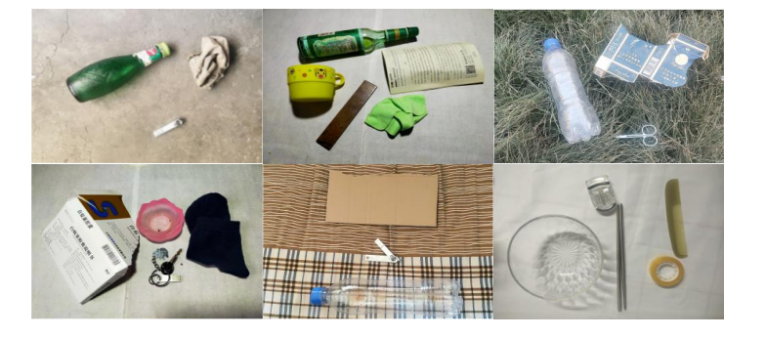

Figure 3-1 Example of MULTI-TRASH Image

**3.1.2 Data annotation**

Due to the fact that the model experiment in this article relies on accurate annotation of each category in the garbage image dataset, in order to

To ensure the accuracy of dataset annotation, 6 experts with professional knowledge in garbage classification were invited to carry out dataset annotation work. Firstly, three experts will perform a preliminary annotation on the dataset. Next, two other experts will check the labels marked by the first three experts and correct the incorrect labels. Finally, the remaining expert checks all labels to ensure consistency in the labeling results. This article uses the LabelImg annotation tool to annotate garbage images, using rectangular boxes of different colors to indicate different categories of garbage. Each image corresponds to an XML document, saving the garbage category information in each image. The annotated dataset is shown in Figure 3-2.

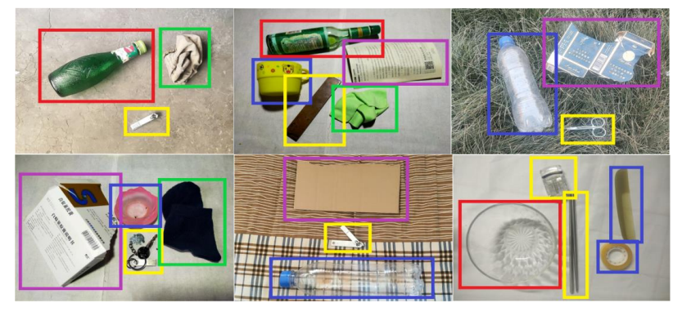

Figure 3-2 Example of annotation for the MULTI-TRASH dataset

**3.1.3 Small size garbage image recognition problem**

The size (in pixels) distribution of garbage in the dataset is shown in Figure 3-4. As can be seen,the number of garbage targets with a size of less than 1 million pixels accounts for a large part of the entire data set. In order to make the model experiment results more obvious, scrap metal was deliberately selected as small-scale garbage when collecting the data set, that is, the size of garbage such as scrap metal in the collected data set is generally small. Small garbage targets occupy a small area of the entire image, have low resolution, and carry little feature information, resulting in weak feature expression ability, limited available features, and are susceptible to noise interference [60]. In the process of feature extraction in the network, due to the presence of pooling layers, the expression ability of deep features to small-scale garbage is weak, and the scale of the feature map is continuously reduced due to downsampling and feature extraction, resulting in the loss of feature information of small-scale garbage in the final feature map [61], making it difficult for convolutional neural networks to recognize small-scale garbage.

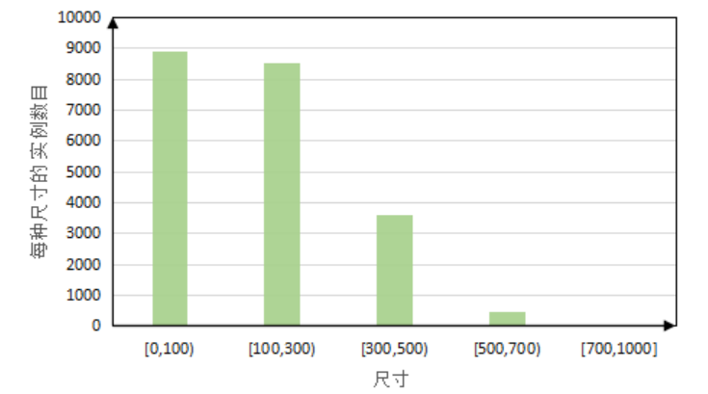

Figure 3-4 Garbage Size Distribution

**3.2 Method for constructing feature fusion models**

Due to the diversity of the garbage image dataset constructed in this chapter, there are differences between different types of garbage in the image

Display size differences. Using YOLOv4 network for garbage recognition, in the backbone feature extraction network.When constructing CSPDarknet53, if only a fixed size convolutional kernel is used to extract the feature information of each layer, the various feature information of different sizes of garbage in the image cannot be fully included in the final feature map obtained by the target detection network, leading to the problem of missed or false detection of small size garbage in the recognition model. (1) To address this issue, this chapter constructs a Multi scale Feature Extraction Module (MsFEM) in the backbone feature extraction network section of YOLOv4. The structural diagram of MsFEM is shown in Figures 3-6, where s and m represent two different sizes of convolutional kernels, respectively. The purpose of using two different size convolution kernels, s and m, to extract the features of garbage images is to use different size Receptive field for the input images, the large Receptive field extract the feature information of large size garbage, and the small Receptive field extract the feature information of small size garbage. In order to transmit the feature information of different sizes of garbage extracted by the multi-scale feature extraction module to the deep feature extraction network, the feature maps extracted by these two convolutional kernels are concatenated and transmitted to the next layer of network.

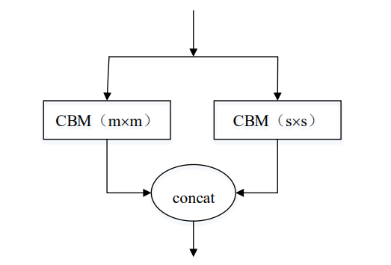

The overall model structure of the improved NWNU-YOLOv4 is shown in Figures 3-8. On the basis of YOLOv4 model.On this basis, the MsFEM module is added to the backbone feature extraction network, and the garbage features in the image are extracted through two convolutional kernels of different sizes. Then, the features extracted from these two convolutional kernels are concatenated and continued to be transmitted to the next layer of the network. An EFFM module has been added to the feature pyramid section to enhance the model's recognition performance for small-scale garbage.

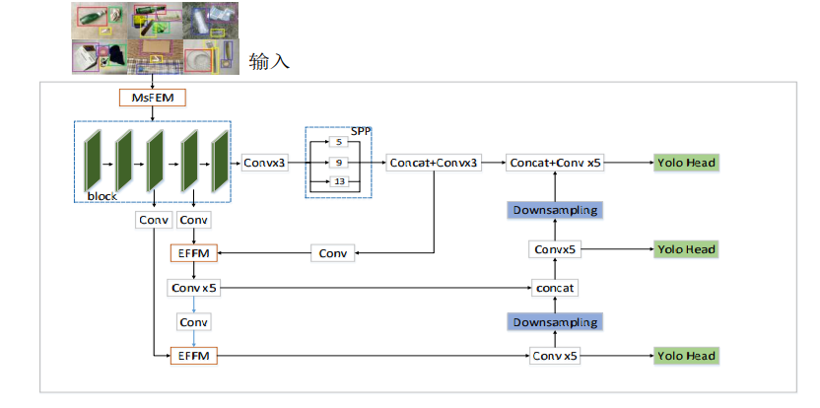  
Figure 3-8 Structure diagram of NWNU-YOLOv4 model

**3.3 Experiment and analysis**

Figures 3-9 show the recognition performance of the NWNU-YOLOv4 model constructed in this chapter. Map the garbage to be identified

The automated recognition was performed on the trained NWNU-YOLOv4 model, and the recognition results are shown in the figure. The location of each garbage is marked by a green rectangular box, and the category and confidence level of the garbage recognized by the model are displayed above the rectangular box. It can be seen that the model has achieved good recognition performance on all garbage categories. Specifically, the model can effectively identify small sized garbage in images, indicating that the improved methods in this chapter can improve the model's ability to recognize small sized garbage.

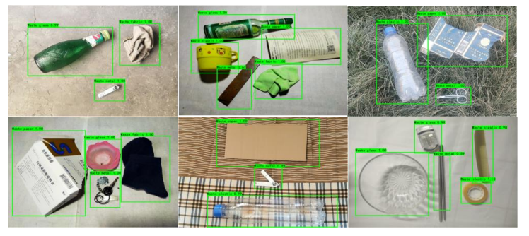

Figure 3-9 Example of NWNU-YOLOv4 model recognition results

Figure 3-10 shows the loss value variation curve of NWNU-YOLOv4, and Table 3-5 shows NWNU-YOLOv4.The performance results of each garbage category in the model on various evaluation indicators. The experimental results show that the Precision value of the NWNU YOLOv4 model is 95.01%, the Recall value is 92.40%, and the F1 score value is 93.68%. Figures 3-11 show the Precision recall curve of the NWNU-YOLOv4 model.

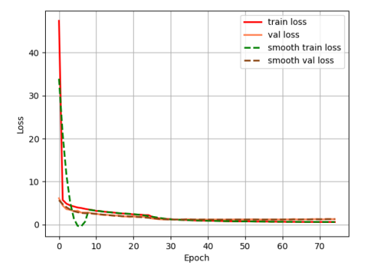

Figure 3-10 Loss value variation curve of NWNU-YOLOv4

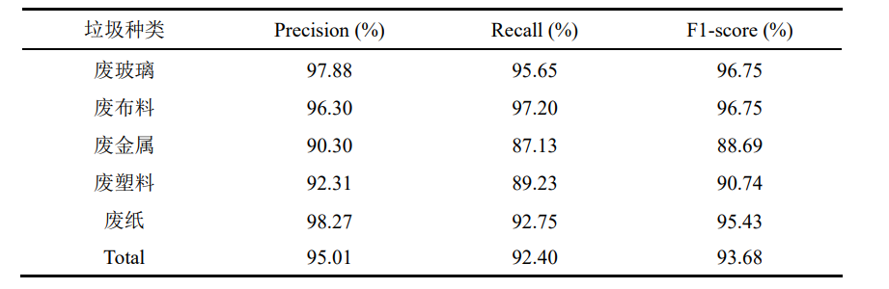

Table 3-5 Experimental Results of NWNU-YOLOv4

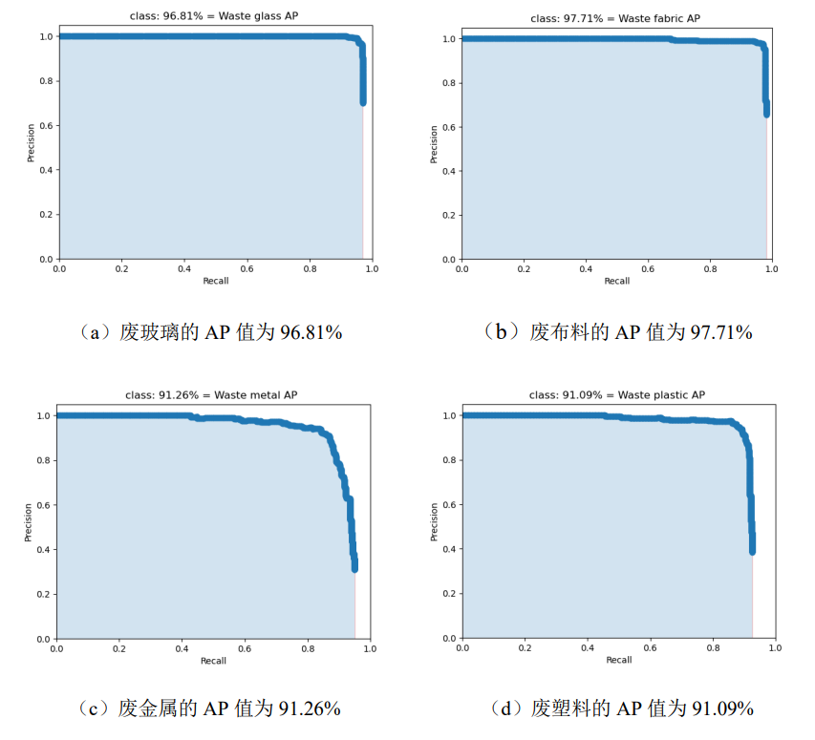

Figure 3-11 Precision recall curve of NWNU-YOLOv4 mode

From the graph, it can be seen that the red curve represents the error detection rate of the improved model constructed in this chapter on the dataset, which is at the bottom of all curves, it indicates that the model constructed in this chapter has the lowest overall false detection rate for all garbage categories. SSD algorithm has the highest corresponding curve, that is, the highest false detection rate, especially in the category of scrap metal, which indicates that SSD algorithm is not suitable for experiments on the data set in this chapter, and is not friendly to the recognition effect of small-scale garbage. On the category of waste fabric, the error detection rate of all curves is the lowest. According to Table 3-4, the AP values of all models on waste fabric are also the highest, indicating that the recognition model used in this chapter has the best recognition effect on waste fabric. This is because this type of waste has equal size, rich features, and strong feature expression ability. All the curves reach the peak value in the category of scrap metal, which means that scrap metal has the highest false detection rate in all waste categories. This is because scrap metal belongs to small-scale waste in this experimental data set, and the recognition effect is poor compared with other types of waste. The false detection rate of the NWNU-YOLOv4 model built in this chapter is significantly lower than that of other models in the category of scrap metal, The false detection rate on other categories is also lower than other models, indicating that the recognition model constructed in this chapter can indeed improve the recognition effect of small-scale garbage.

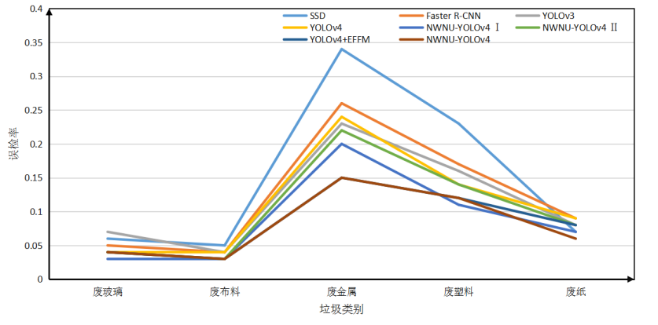

Figure 3-12 Misdetection rates of various models

**4 References**

[1] Girshick R, Donahue J, Darrell T, et al. Rich feature hierarchies for accurate object detection and semantic segmentation[A]. Proceedings of the IEEE Conference on Computer Vision and Pattern Recognition[C]. New York, USA: IEEE, 2014. 580-587.

[2] Girshick R. Fast r-cnn[A]. Proceedings of the IEEE International Conference on Computer Vision[C]. Kerkyra, Greece: IEEE, 2015. 1440-1448.

[3] Zeng L, Sun B, Zhu D. Underwater target detection based on faster r-cnn and adversarial occlusion network[J]. Engineering Applications of Artificial Intelligence, 2021, 100:104190.

[4] Duan M, Wang G P, Niu C Y. Method of small sample size image recognition based on convolution neural network[J]. Computer Engineering and Design, 2018, 39(1):224-229.

[5] Visa S, Ramsay B, Ralescu A L, et al. Confusion matrix-based feature selection[J]. MAICS, 2011, 710:120-127.

[6] Wixted J T, Mickes L, Wetmore S A, et al. ROC analysis in theory and practice[J]. Journal of Applied Research in Memory and Cognition, 2017, 6(3):343-351.

[7] Huang Jipeng, Shi Yinghuan, Gao Yang Multi scale Faster RCNN detection algorithm for small targets [J] Computer Research and Development, 2019, 56 (2): 319-327

[8] Li Kecen, Wang Xiaoqiang, Lin Hao, et al Overview of Single Stage Small Object Detection Methods in Deep Learning [J] Computer Science and Exploration, 2022, 16 (1): 41-58

[9] Yang Shuqin, Liu Jiangchuan, Xu Keke, et al Corn stamen drone remote sensing image recognition based on improved CenterNet [J] Journal of Agricultural Machinery, 2021, 52 (9): 206-212

**5 appendix**

In order to solve different problems in the field of garbage classification, different garbage classification datasets were constructed and trained

Different garbage classification models have been developed. The experimental results show that the garbage classification model constructed in this paper performs well in both recognition accuracy and recognition speed, and is suitable for practical garbage classification scenarios. This article has the following prospects: (1) Although the garbage image dataset constructed in this article has different lighting intensities, they are all taken during the day and are not suitable for garbage image recognition work at night. In future research, nighttime garbage image datasets can be collected and the model trained using nighttime images, making the model not only suitable for daytime garbage classification, but also suitable for nighttime. (2) This article constructs single target and multi-objective garbage classification models, which can effectively improve the efficiency of garbage classification based on image recognition. In the next stage of research, the garbage classification model constructed in the paper can be combined with garbage classification related facilities through on-site research to apply it to actual garbage classification work.

**6 Code**

import os

import numpy as np

import matplotlib.pyplot as plt

import tensorflow as tf

from tensorflow.keras.preprocessing.image import ImageDataGenerator

from tensorflow.keras.models import Sequential

from tensorflow.keras.layers import Dense, Conv2D, MaxPooling2D, Dropout, Flatten

*# 设置参数*

train_directory = 'train_set/'

test_directory = 'test_set/'

validation_directory = 'val_set/'

img_height, img_width = 224, 224

batch_size = 128

epochs = 30

learning_rate = 0.0001

num_classes = 6

*# 创建数据增强器*

train_datagen = ImageDataGenerator(

rescale=1./255,

rotation_range=40,

width_shift_range=0.2,

height_shift_range=0.2,

shear_range=0.2,

zoom_range=0.2,

horizontal_flip=True)

test_datagen = ImageDataGenerator(rescale=1./255)

*# 加载数据*

train_data = train_datagen.flow_from_directory(train_directory,

target_size=(img_width, img_height),

batch_size=batch_size,

class_mode='categorical')

test_data = test_datagen.flow_from_directory(test_directory,

target_size=(img_width, img_height),

batch_size=batch_size,

class_mode='categorical')

val_data = test_datagen.flow_from_directory(validation_directory,

target_size=(img_width, img_height),

batch_size=batch_size,

class_mode='categorical')

*# 定义模型*

model = Sequential()

model.add(Conv2D(32, (3, 3), activation='relu', input_shape=(img_width, img_height, 3)))

model.add(MaxPooling2D((2, 2)))

model.add(Conv2D(64, (3, 3), activation='relu'))

model.add(MaxPooling2D((2, 2)))

model.add(Conv2D(128, (3, 3), activation='relu'))

model.add(MaxPooling2D((2, 2)))

model.add(Conv2D(256, (3, 3), activation='relu'))

model.add(MaxPooling2D((2, 2)))

model.add(Flatten())

model.add(Dense(512, activation='relu'))

model.add(Dropout(0.5))

model.add(Dense(num_classes, activation='softmax'))

*# 编译模型*

optimizer = tf.keras.optimizers.Adam(lr=learning_rate)

model.compile(optimizer=optimizer,

loss='categorical_crossentropy',

metrics=['accuracy'])

*# 训练模型*

history = model.fit(train_data,

epochs=epochs,

validation_data=val_data)

*# 测试模型*

score = model.evaluate(test_data)

print('Test accuracy:', score[1])

*# 绘制训练和验证损失图*

acc = history.history['accuracy']

val_acc = history.history['val_accuracy']

loss = history.history['loss']

val_loss = history.history['val_loss']

epochs_range = range(len(acc))

fig, ax = plt.subplots(nrows=1, ncols=2, figsize=(10, 5))

ax[0].plot(epochs_range, acc, label='Training Accuracy')

ax[0].plot(epochs_range, val_acc, label='Validation Accuracy')

ax[0].set_title('Training and Validation Accuracy')

ax[0].legend(loc='lower right')

ax[0].set_xlabel('Epoch')

ax[0].set_ylabel('Accuracy')

ax[1].plot(epochs_range, loss, label='Training Loss')

ax[1].plot(epochs_range, val_loss, label='Validation Loss')

ax[1].set_title('Training and Validation Loss')

ax[1].legend(loc='upper right')

ax[1].set_xlabel('Epoch')

ax[1].set_ylabel('Loss')

plt.show()